**DBAS32100: Database Management**

**Title: Group Project Part B**

**Date of Submission: 12th August 2021**

**Submitted By: Late-Night Code Co.**

**Group Name: Late-Night Code Co.**

**First and Last Name: Rajpara Dhruv Kamleshkumar Student_ID: 991575895**

**First and Last Name: Patel Devansh Student_ID: 991574941**

**First and Last Name: Patel Shreya Student_ID: 991561893**

**Instructor: Prof. Sukhpal Ghuman**

**Create all The tables**

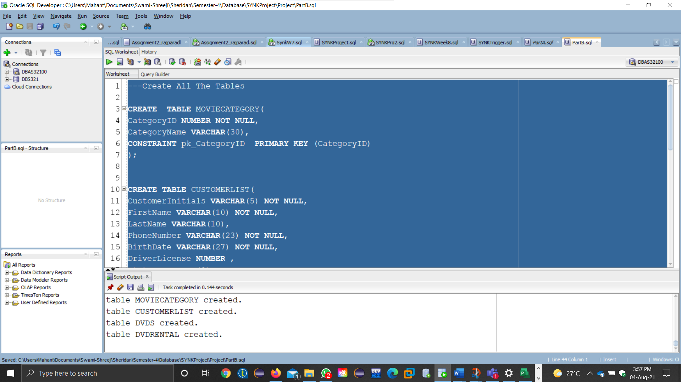

**Create New Job In Talend**

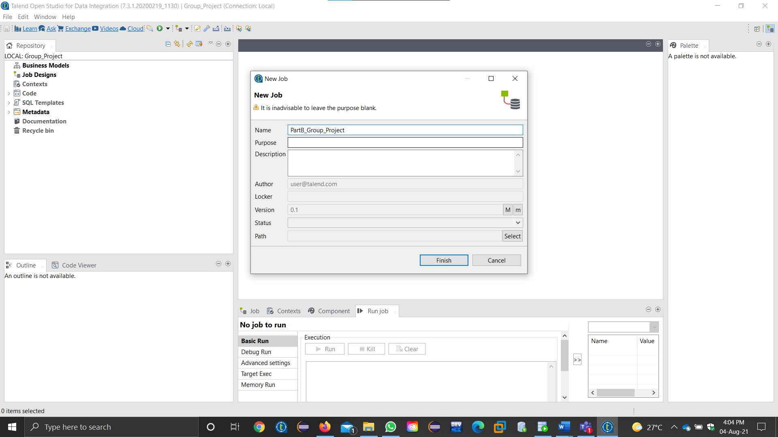

**Files Delimited For all .csv files**

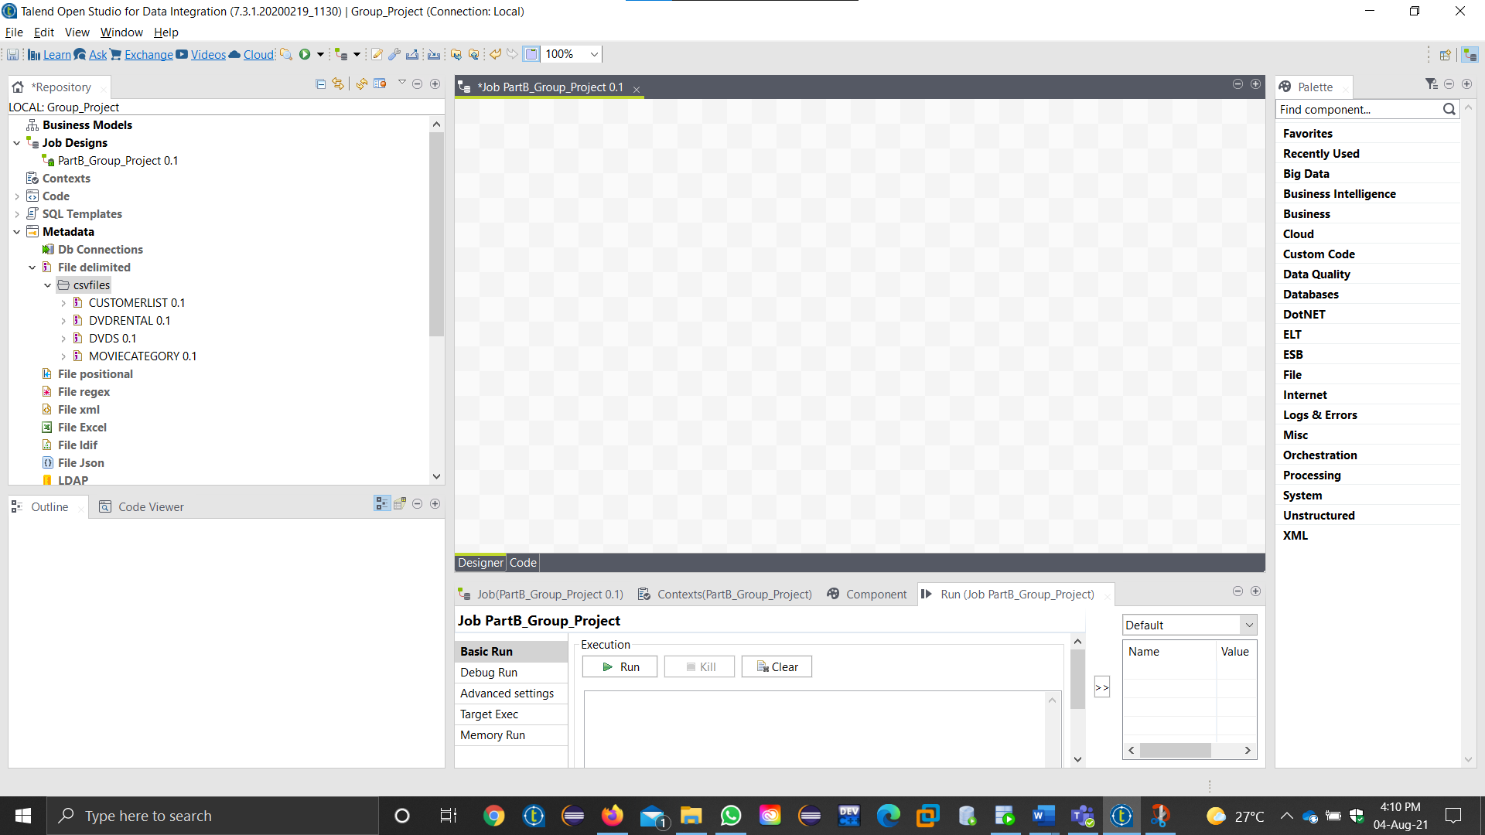

**Testing the Connections**

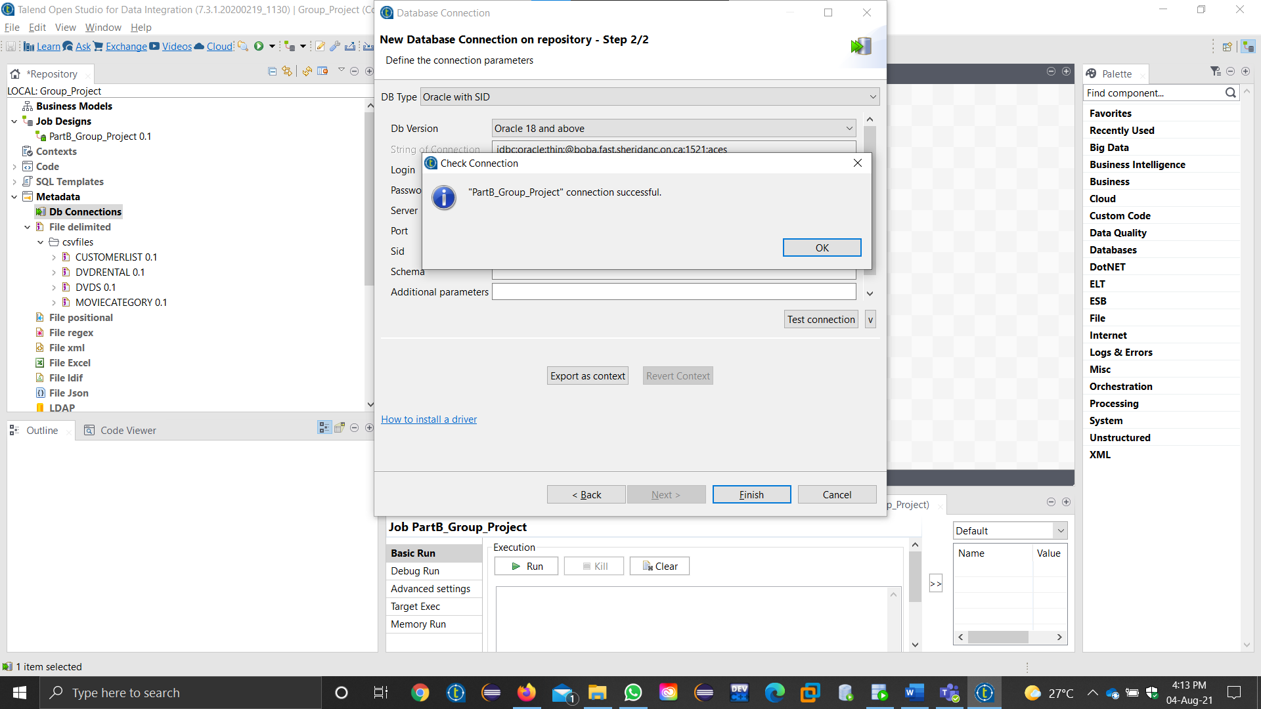

**Connection Success while Retrieving the Schema For all 4 tables**

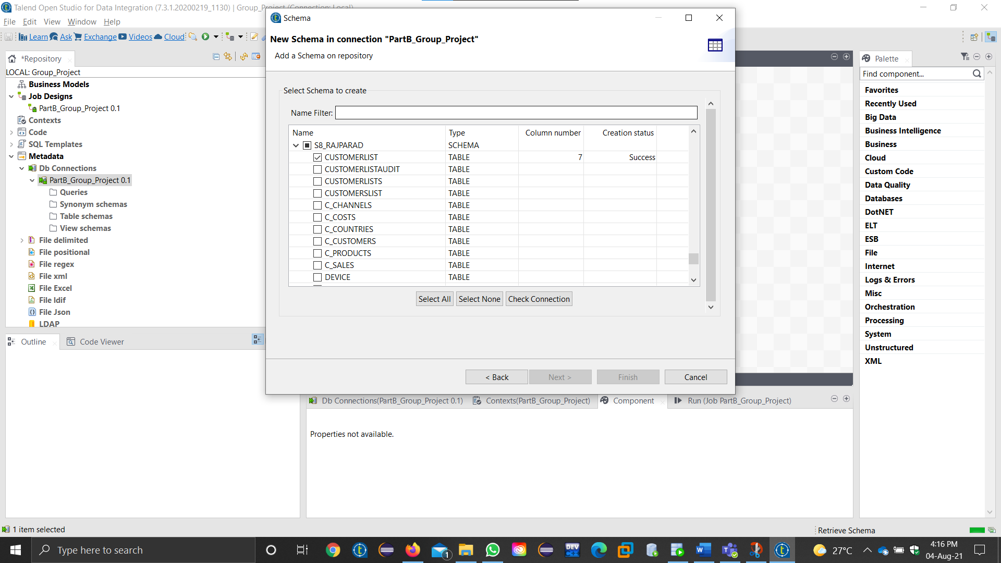

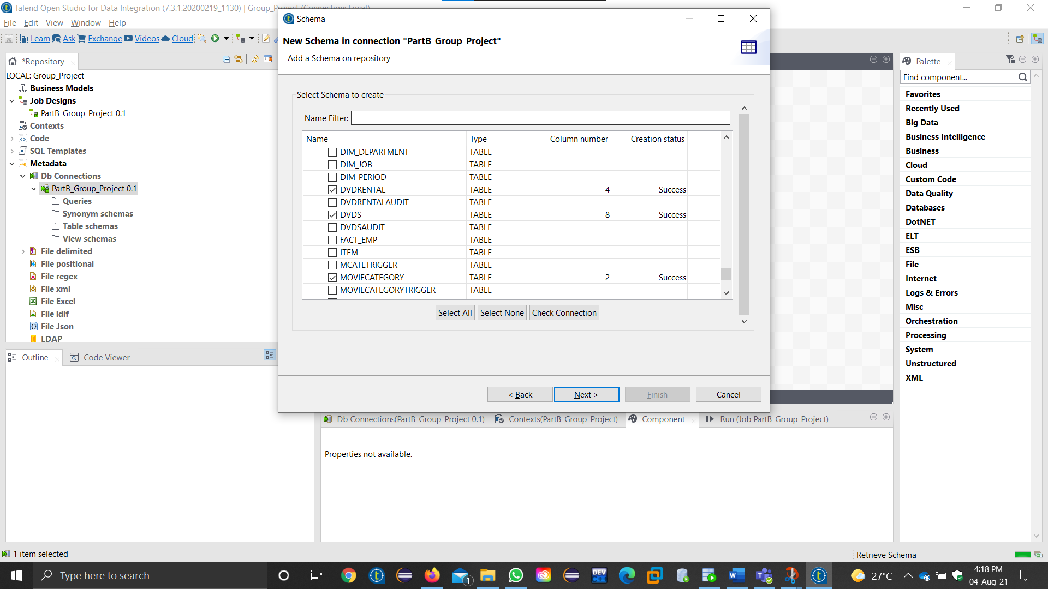

**MOVIECATEGORY TABLE**

tmap Configuration for 2 fields

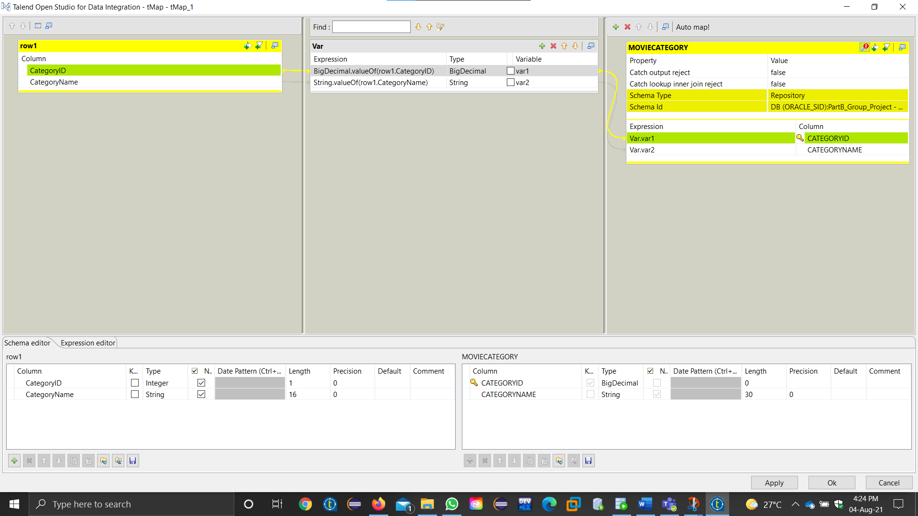

Job Run Successful

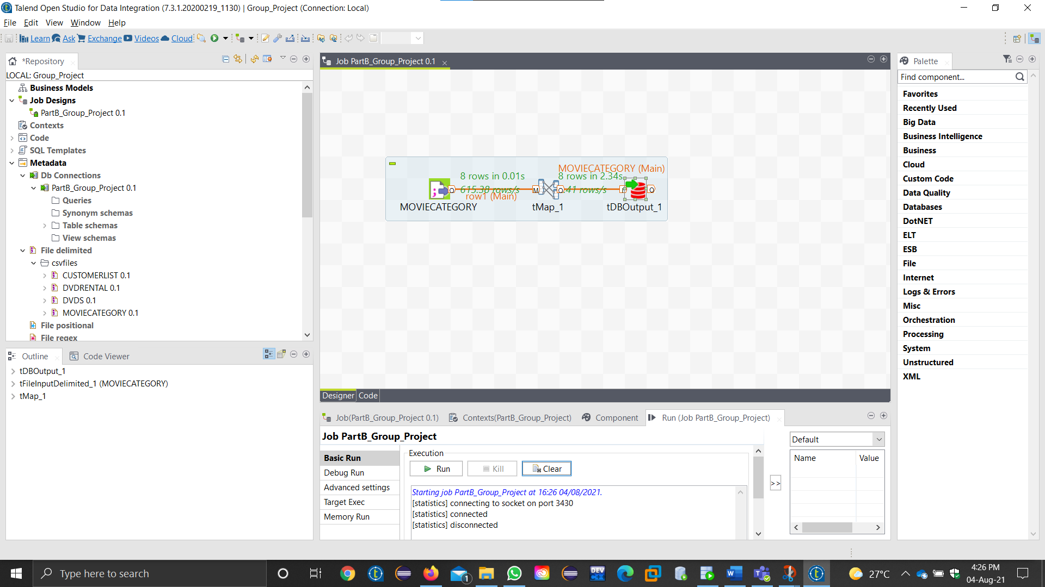

Selecting the Data from MOVIECATEGORY TABLE

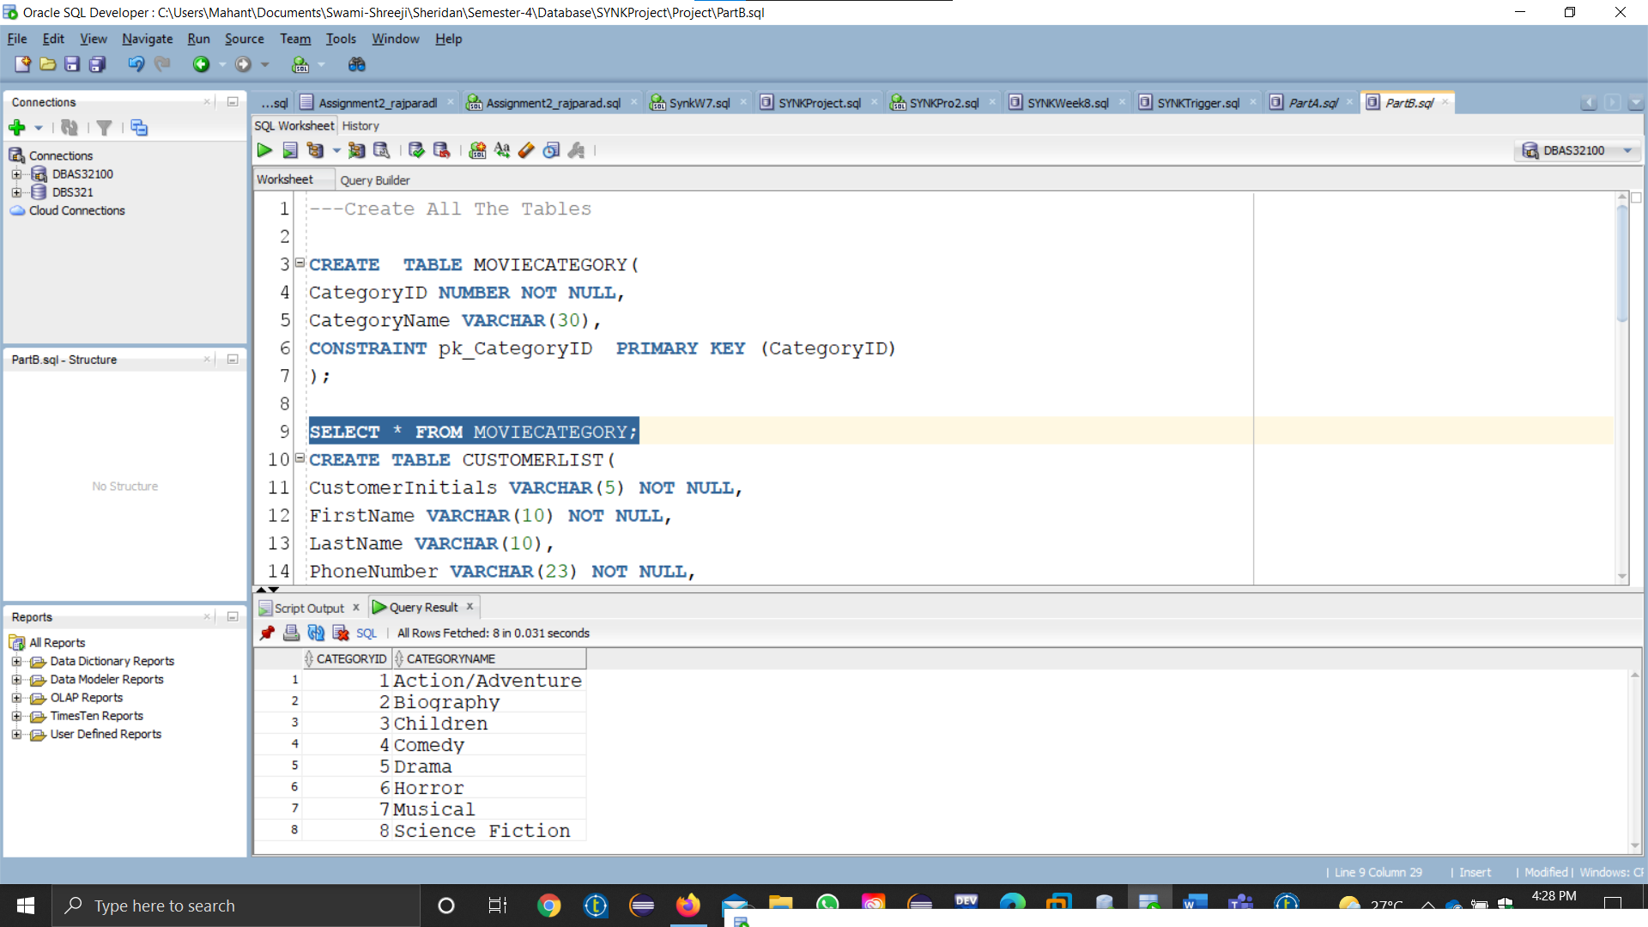

**CUSTOMERLIST TABLE**

tmap Configuration for fields

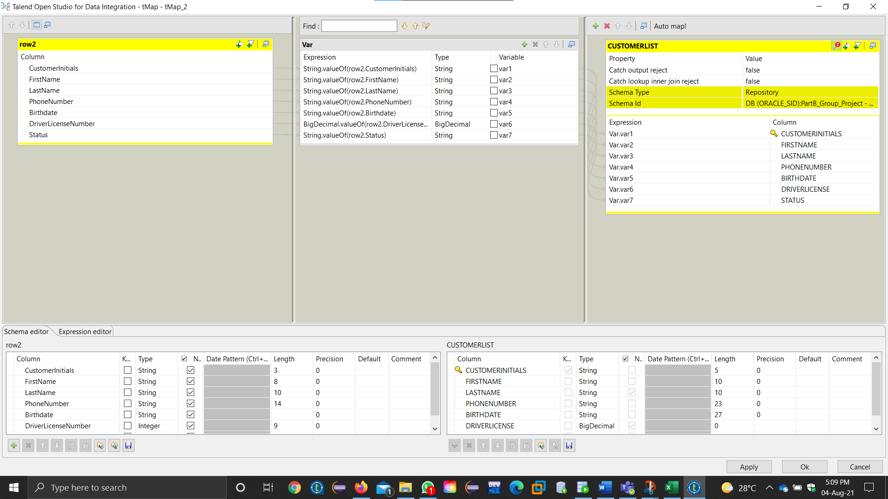

Job Run Successful

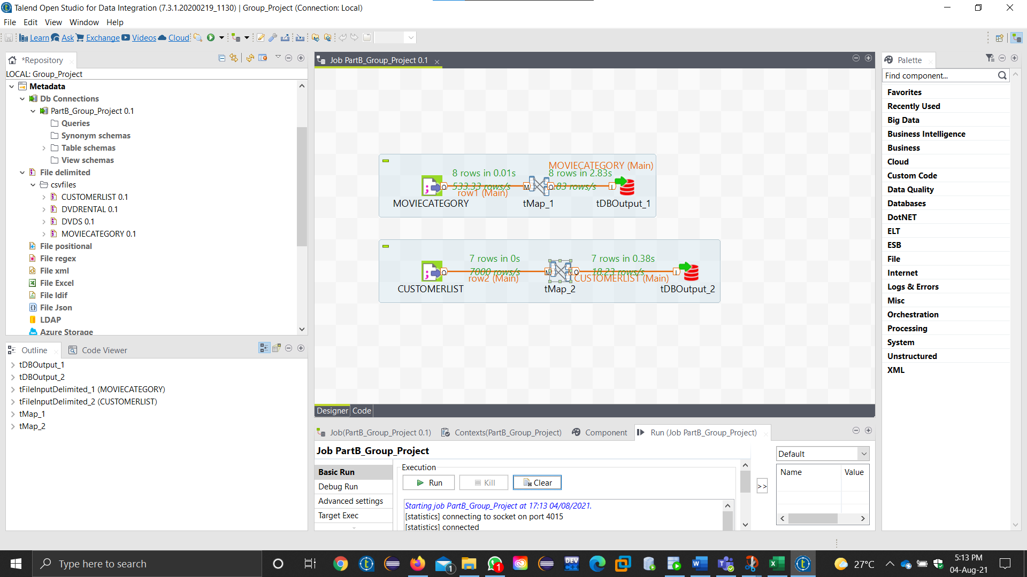

Selecting the Data from CUSTOMERLIST TABLE

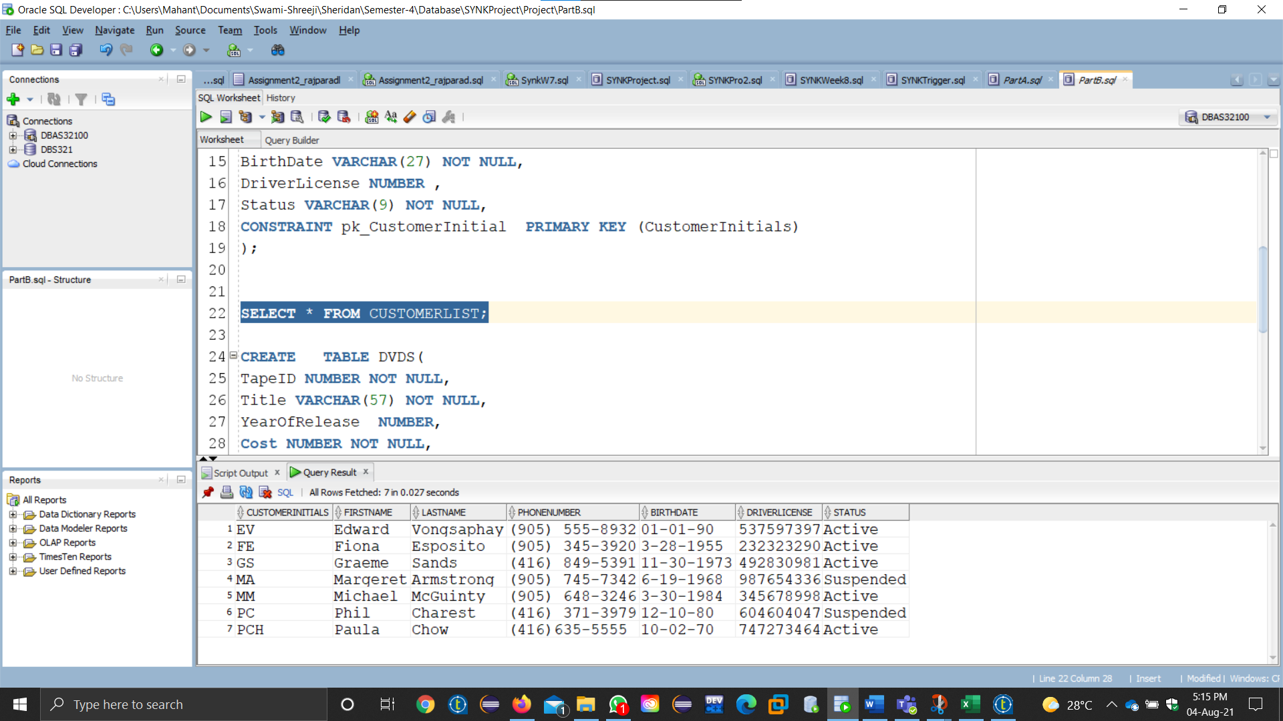

**DVDS TABLE**

tmap Configuration for fields

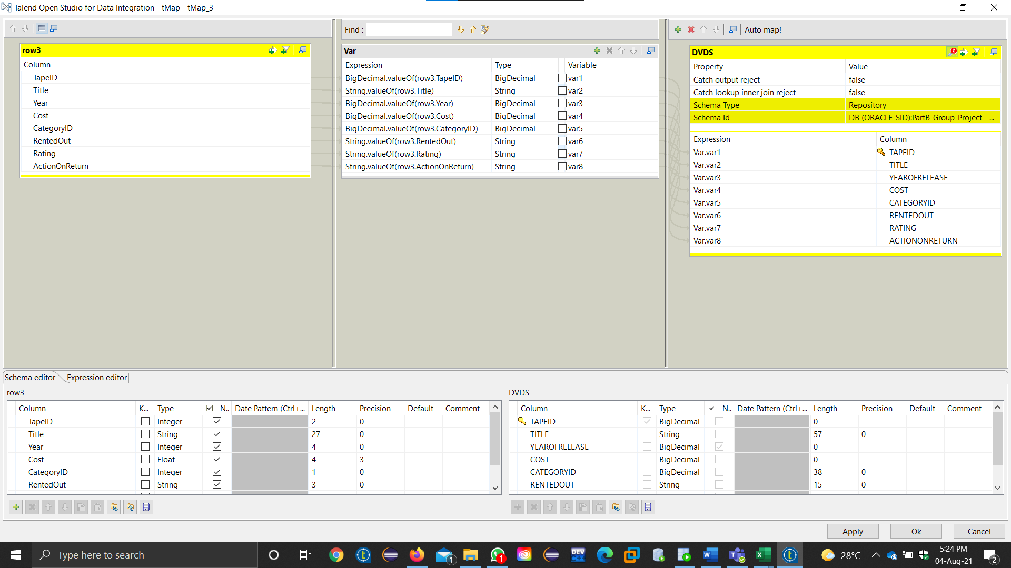

Job Run Successful

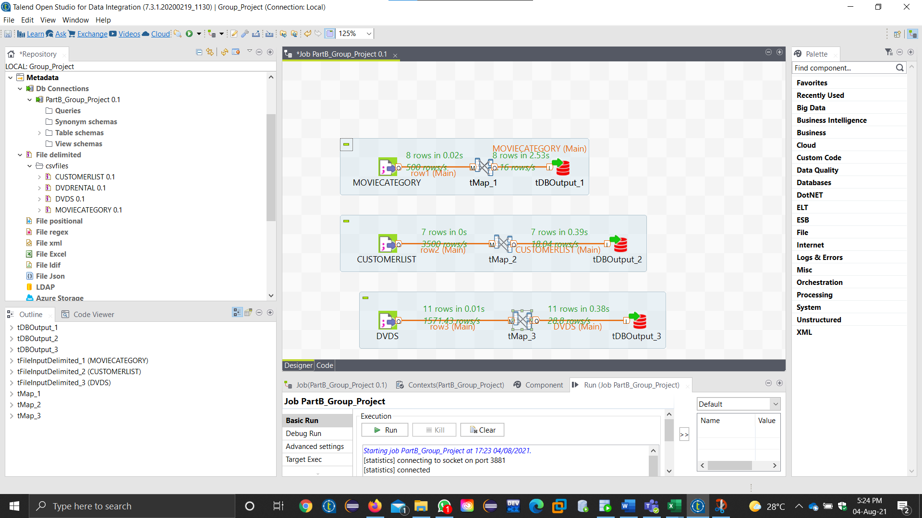

Selecting the Data from DVDS TABLE

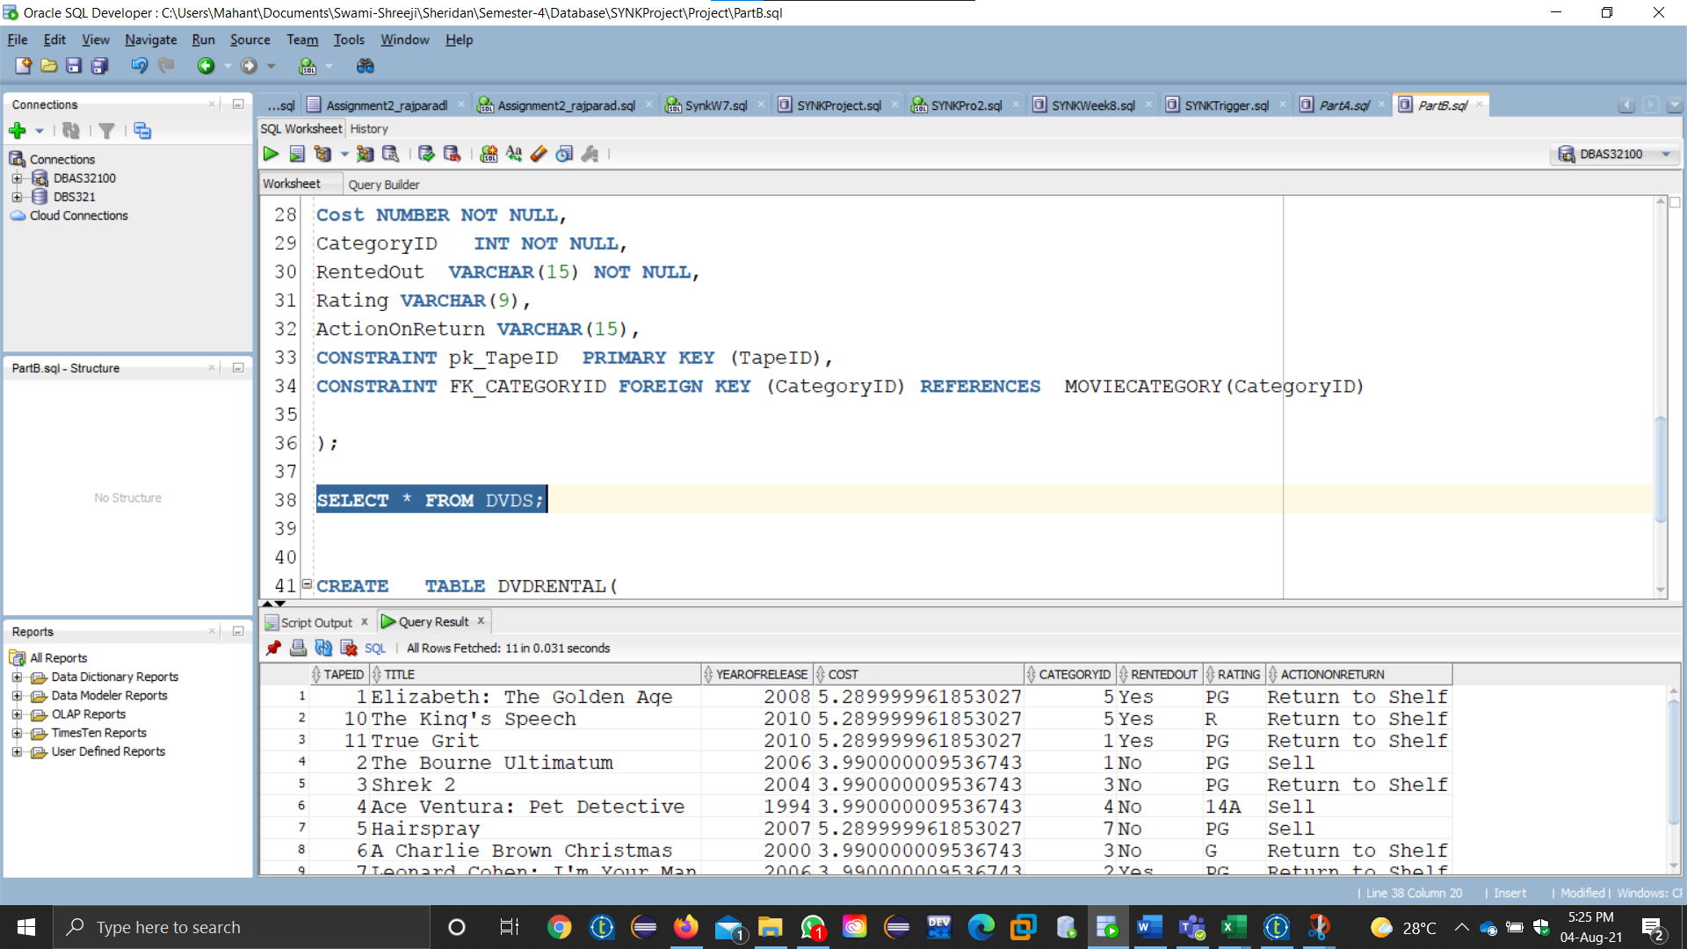

**DVDRENTAL TABLE**

tmap Configuration for fields

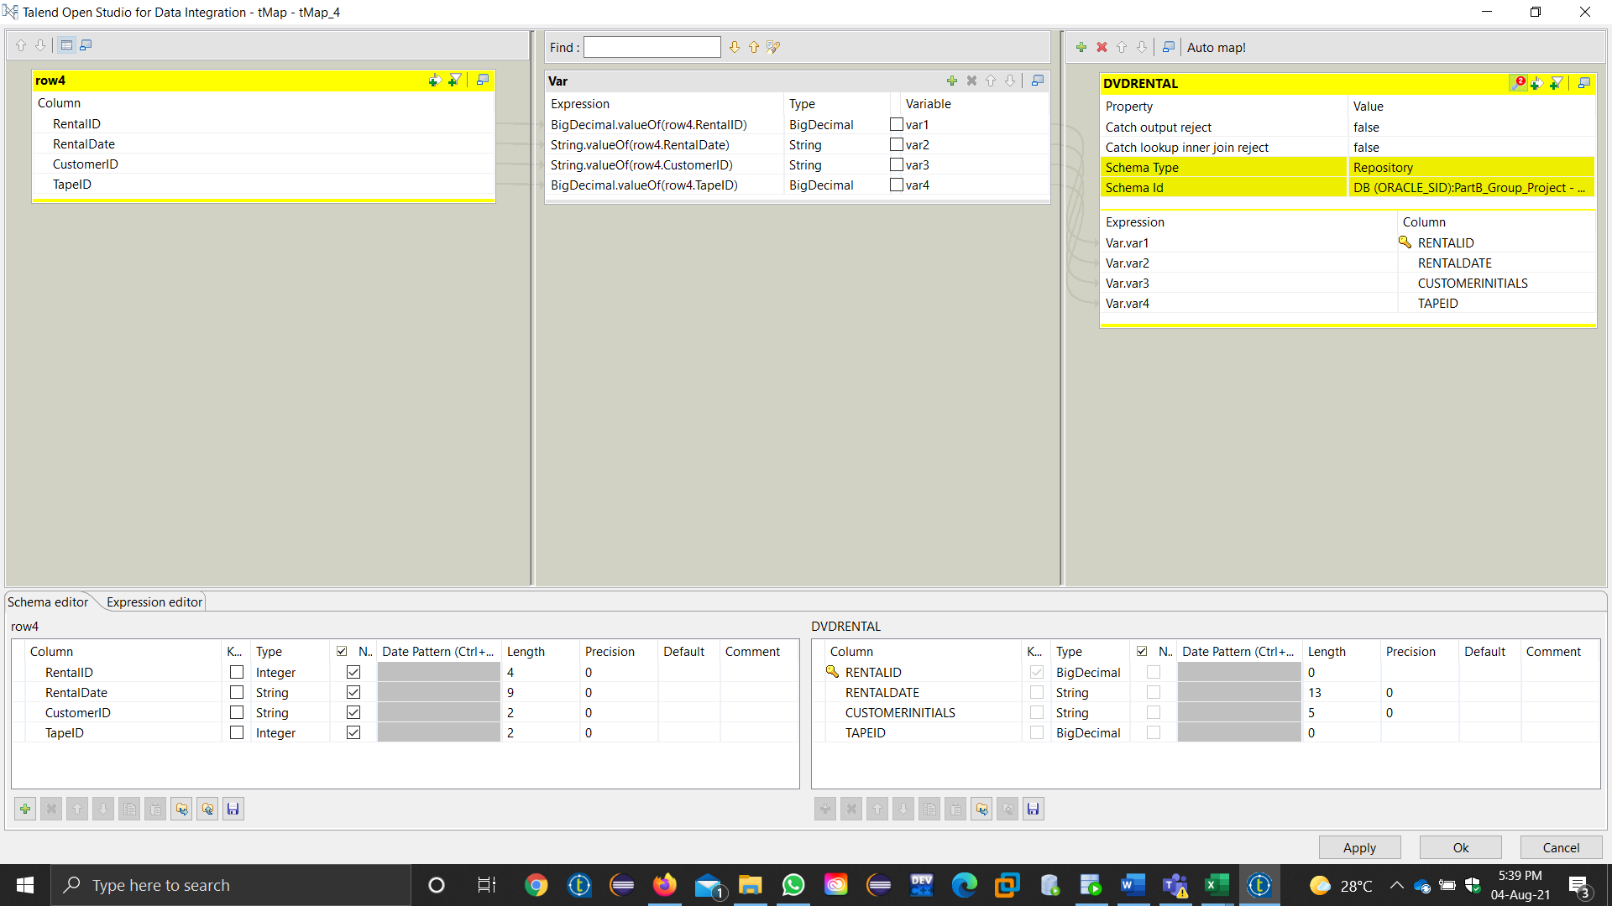

Job Run Successful

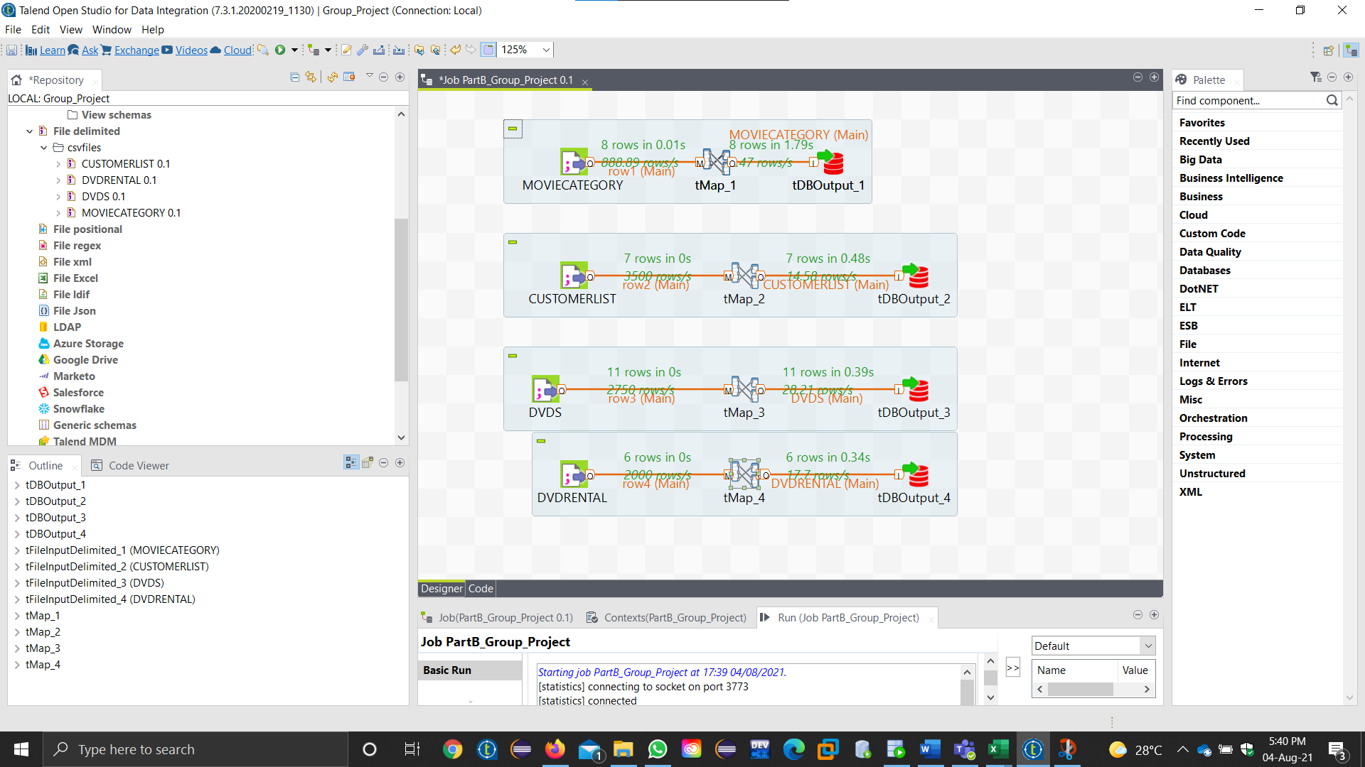

Selecting the Data from DVDRENTAL TABLE

